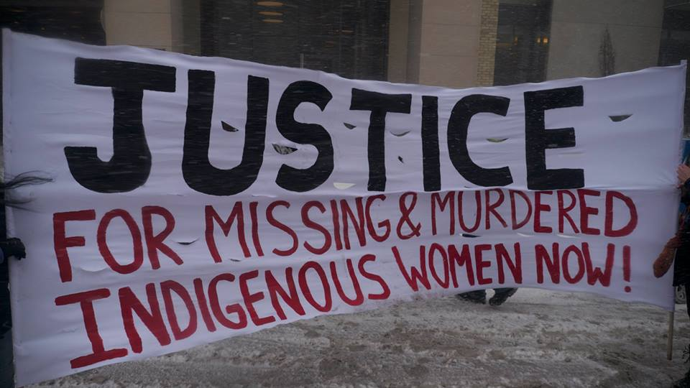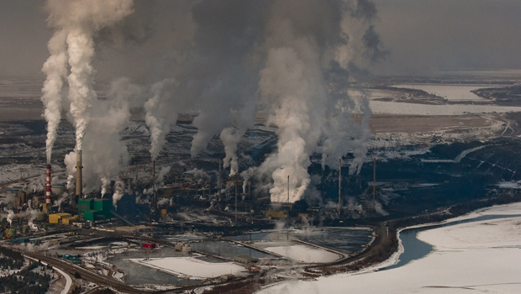

Counting the Cost:

Social Justice in Canada?

* How is it that Dawson College sits on the unceded land of the Mohawk peoples and yet it was purchased by the Quebec government from an order of Catholic nuns?
* Why is it that immigrants aren’t having their credentials recognized here in Canada so that men and women with medical degrees and PhDs are driving taxis or working in the service industry?
* What are the real risks concerning the B.C. Oil Pipeline and will the protests make a difference?

These are just some of the big social justice issues confronting us today that will serve as launching points for our work in ***Counting the Cost:  Social Justice in Canada?***

Are you a Social Science student who needs a **QM for Fall 2017**?

Would you like to complete your QM course requirement along with a Social Science option course at the same time? Consider enrolling in the Learning Community **Counting the Cost: Social Justice in Canada?** which combines **Quantitative Methods + Canadian History**

**What will we be doing in this course?**

This course pairing of **Quantitative Methods (300- 360-DW) + Canadian History (330-201 DW)** begins by looking at the current state of our society and then digs back into the past to explore the roots of these social justice issues through hands-on research. We will be going out into the community, watching documentaries, hearing from experts, and getting our hands dirty in the archives in order to build research projects that bridge classroom learning and social activism.

**What’s a paired course Learning Community, you ask?**

A learning community is **two courses focused on a single interesting theme.** The teachers of those two courses will work closely together to integrate their course activities so that the work done in one class will help you to complete the work for the other. You will need to preregister for these courses by getting in touch with Max Jones at mjones@dawsoncollege.qc.ca

**Questions?** Please see Ben Lander (Quantitative Methods) or Elizabeth Kirkland (Canadian History), both located in 3E.15.