I was introduced to the idea of universal design for learning purely by accident, while looking for guidelines for how to integrate a physically disabled student into a physically demanding course. What I discovered was a new set of lenses through which to look at teaching and learning that will benefit all of my future students, by helping them to be less impacted by barriers in the classroom and pedagogical design.
The UDL philosophy makes sense to me on many different levels. Not only do we have increasing numbers of students coming into our program with recognized learning difficulties of various types, we have students who face a wide variety of other challenges. One of those challenges is time. Our course content is dense; we are preparing professionals who will graduate able to register for a professional body and treat patients, so the responsibility to ensure that our graduates match the exit profile is critical. But our students struggle to keep up, to prioritize, and to “get it all done”. Some have children, many have jobs, others live in the suburbs and have a 2 hour commute each day. Some have just graduated from high-school and have not experienced the latitude and accompanying responsibility of studying at college. Many have not yet mastered the academic skills that will carry them through.
Our courses are hands-on, so an active learning environment naturally follows, and I fully embraced these instructional methods from my first day of teaching even though I may not have been naturally very good at it, having had few models to work from, coming from a generation of learners who were taught primarily using the “sage-on-the-stage” model. I recognized even before beginning that I preferred not to teach that way, mostly because it didn’t work so well for me as a student. So, I tried to create my course for students like me. Now I realize that not all students are like me, in fact no two students learn in exactly the same way (see “myth of the average student” video below). UDL just makes sense in that it gets through to the greatest variety of learners.
To present my portfolio, I decided to create a video module similar to the ones I created for my course using my UDL release time. This module has been created with my department colleagues as the intended audience, so some context might be helpful here. I work in Physiotherapy Technology, a small department of about 10 faculty. Our program is growing; we doubled our cohort size from about 25 to 50 last year. The course I worked on primarily was called “Interventions in Vascular and Respiratory Conditions”, though the design principles now permeate everything I do as a teacher.
Our program is relatively new; we are graduating our fourth cohort this year. We are still in the active process of creating/designing our program curriculum and learning underlying pedagogy. It is the perfect time to consider universal design, to anticipate instead of retrofit.
When I took the job at Dawson and decided to become a teacher, I began a process of building expertise in the particular area of physiotherapy I was teaching. I didn’t realize that in my quest to become an expert, I have actually been practicing the strategies to become an expert learner, which CAST defines as:
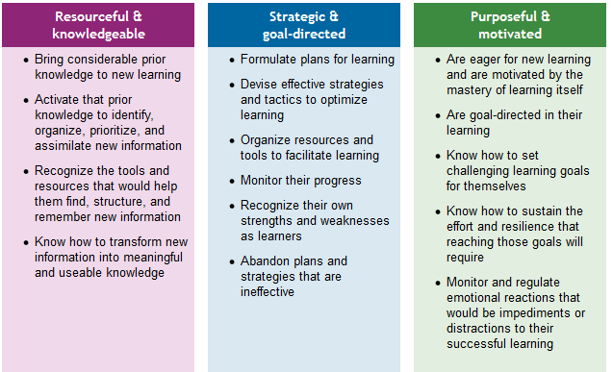

I understand better now the difference between an expert and an “expert learner” now, but I am also becoming more conscious of the need to model this process for my students. I may not have time (or the ministerial competency) to directly include these meta-strategies in my curriculum, but I can show my students by example. Simply recognizing that this is part of my job is already a step in the right direction.
My next steps for this course are outlined in the video: activate and shorten my modules, and work on more structured active learning activities in the classroom. My next step with UDL will take me back to my original problem, which was adapting a heavy course for a physically disabled student. In partnership with my department and the accessibility office, I will consider the paradigm side by side with the accommodations model in order to devise an accommodation policy for our department in order to guide our faculty on these matters in the future.
Here is my powerpoint video portfolio presentation on UDL:
https://web.microsoftstream.com/video/8c48f88a-bf6a-4098-9c27-ed749d2c5ef6

Stuff I made through my participation in the UDL CoP:
  - Flipped module example class
I made about 5 of these, they are still “works in progress”. I would like to re-organize them to be shorter, remove more complex content for the classroom, and make them more interactive.
  - Instructional video on using tech tool in the classroom
Scaffolding for use of tech in the classroom. I made a similar video for study skills and to optimize participation in collaborative documents. Compliance still was not very good. Feedback from the students was that as much as they would like to, if there is no mark associated with an activity, they will not be inclined to do it. Noted.
  - Course assessment template
To use, open link, click “edit” top right corner, then “make a copy” and re-name. Then alter and share as desired).
Inspirational videos:
- CAST 4 minute summary of UD
- “Avoiding death by Powerpoint” video
- “The myth of the average learner”
Resource links:
- UD & technology:
https://udlhcpss.wordpress.com/lesson-redesign/

- BC education resource:

http://udlresource.ca/

- CAST free online book (login/create FREE account to access e-book.)

http://udltheorypractice.cast.org/login

- Collaborative exams - UBC Resource page with links to relevant/convincing research articles and methodology/tips for implementation. Note that not all research has demonstrated improved retention, but several large studies do demonstrate improved retention along with other benefits:

https://blogs.ubc.ca/eoassei/two-stage-exams/

