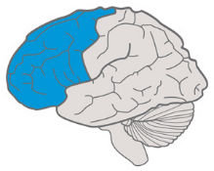
Provide options for Recruiting Interest
Provide options for Perception
Provide options for Physical Action
Provide options for
Sustaining Effort & Persistence
Provide options for Language & Symbols
Provide options for
Expression & Communication
Provide options for Self Regulation
Provide options for Comprehension
Provide options for Executive Functions
Provide multiple means of
Action & Expression
Strategic Networks The “HOW” of Learning
Strategic & Goal-Directed
Resourceful & Knowledgeable
Expert learners who are...

Purposeful & Motivated

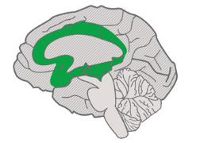
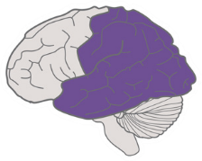
The Universal Design for Learning Guidelines
Provide multiple means of
Engagement
Affective Networks The “WHY” of Learning
Provide multiple means of
Representation
Recognition Networks The “WHAT” of Learning
Access

- Word file with option of reader
- Hands-on component through Moodle & art
- Presentation topic: personal passion
- Art work
- Practical tips to handle stress or forgetting
- Pop up Computers or personal laptops
- Groups of 5 sitting on a round table

- Personal interview with teacher after panel
- Oral presentation + explanation of art
- Evaluation chart with breakdown of criteria
- All panelist required to contribute to one another’s research
- Examples of professional and unprofessional speech
- Multiple versions of question with retry option

- Evaluation forms given beforehand
- Quiz on instructions to verify understanding
- Same evaluation chart & criteria for oneself
- Practical tips to handle stress or forgetting
- Art work
- Visual ranking representation of stages

udlguidelines.cast.org | © CAST, Inc. 2018 | Suggested Citation: CAST (2018). Universal design for learning guidelines version 2.2 [graphic organizer]. Wakefield, MA: Author.
Goal
Internalize
Build

