Goals
What is one goal? | How to train students develop public speaking skills in academic research environments.
Is the how embedded? Does it need to be? | The how is embedded given the nature of the objective.
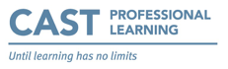
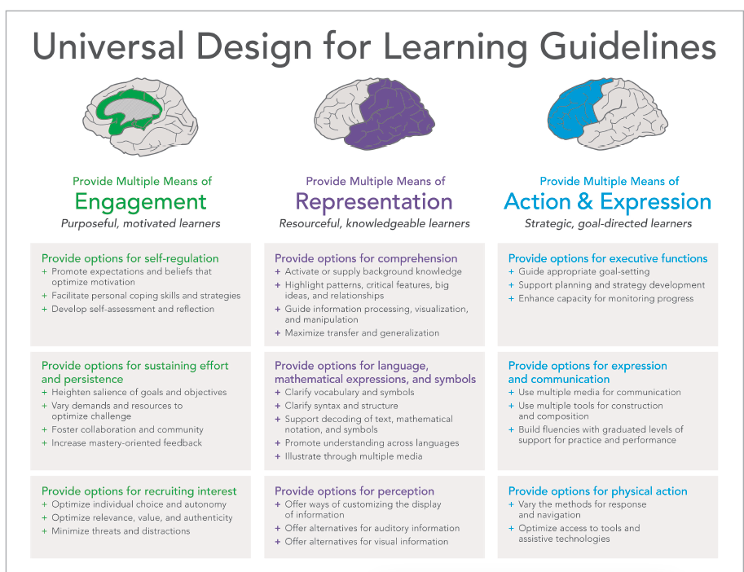
What learning barriers may prevent the student(s) from making progress? What UDL options can be used to address the barriers?

Barrier  e.g., Student sensitive to environment sound | UDL guideline to address barrier  e.g., Offer alternatives to auditory information | Teaching Strategy  e.g., Make headphones  available
Public speaking phobia based on past experience. | Diversify the components involved in the oral presentation to make it more manageable. | Two oral sessions.  Smalls groups.  Five minutes.  Name change: panel discussion.
The oral being an arduous & artificial endeavour. | Recruiting interest, providing alternatives for more personal engagement with the project. | Topic: personal passion.  Oral accompanied by a handmade art work.
Lacking the competence to speak professionally. | Clear syntax and structure. | Instructions & evaluation criteria provided beforehand.  Moodle quiz with good & bad examples.
Not appreciating the value of oral communication in research. | Facilitating interpersonal communication in a way that fosters student autonomy and their value for research. | Bringing a problem to the panel session & receiving advice from panel members.

